SPRINT 2

|  |  |
| --- | --- |
| **Date** | **10 November 2022** |
| **Team id** | **PNT2022TMID53703** |
| **Project name** | **IOT Based Smart Crop Protection System for Agriculture** |
| **Mark** | **20 marks** |

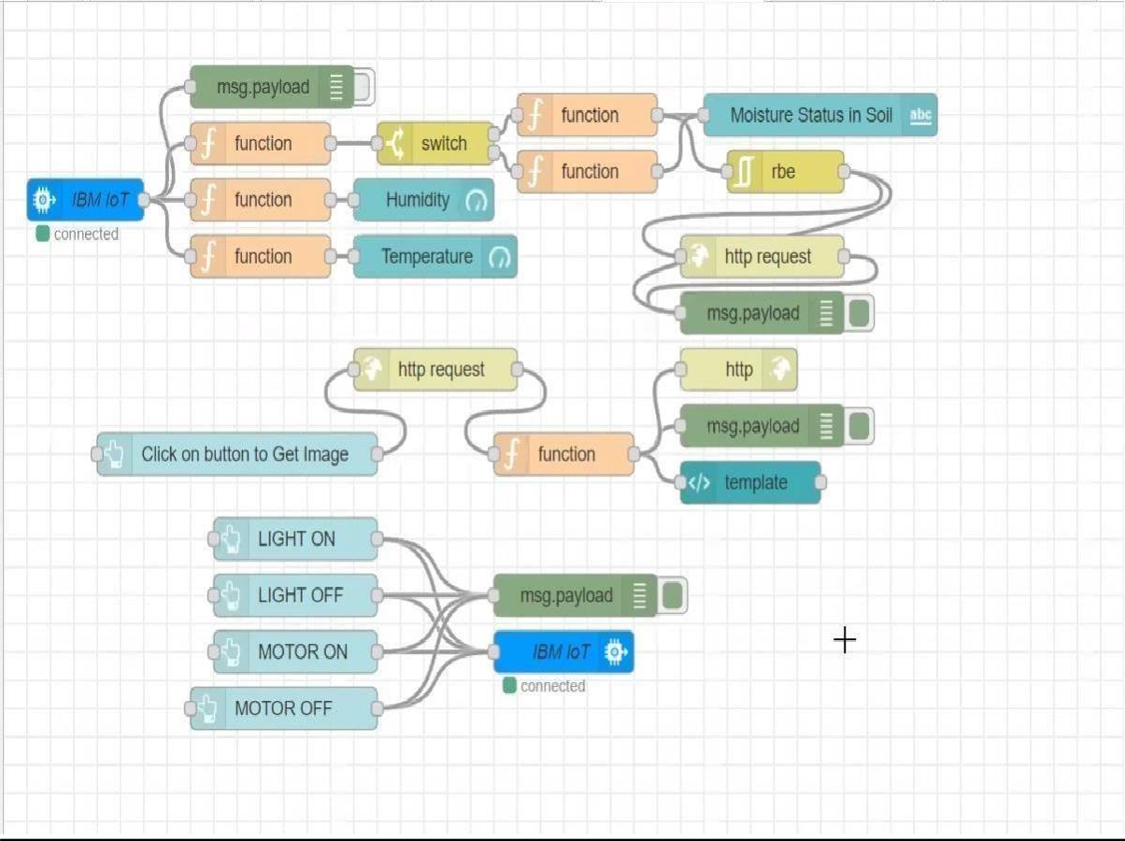

OUTPUT 1:

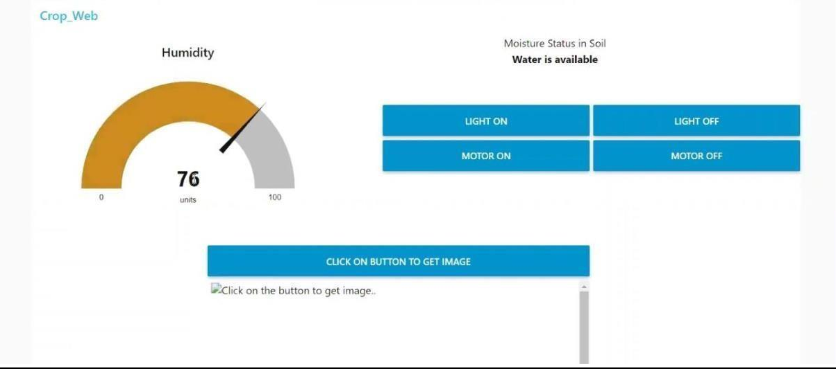

**OUTPUT 2:**

